

For more information, visit the NHS Choices website **www.nhs.uk.**

Most common infections get better without antibiotics.

Find out how you can make better use of antibiotics by visiting: **www.antibioticguardian.com.**

Developed in collaboration with professional medical bodies.

Version: 2 Published: October 2018 Revision date: November 2020

**HOW TO HELP MAKE YOURSELF BETTER**

Whatever your infection, you can do the following to help

Wash your hands to help stop infections spreading

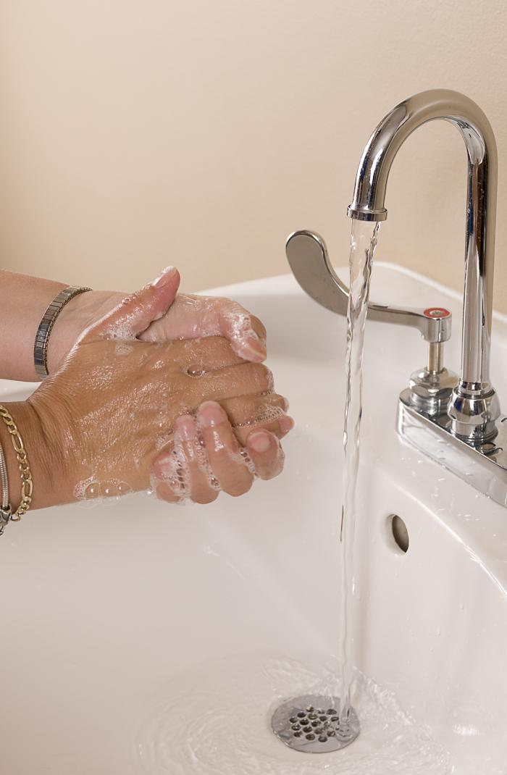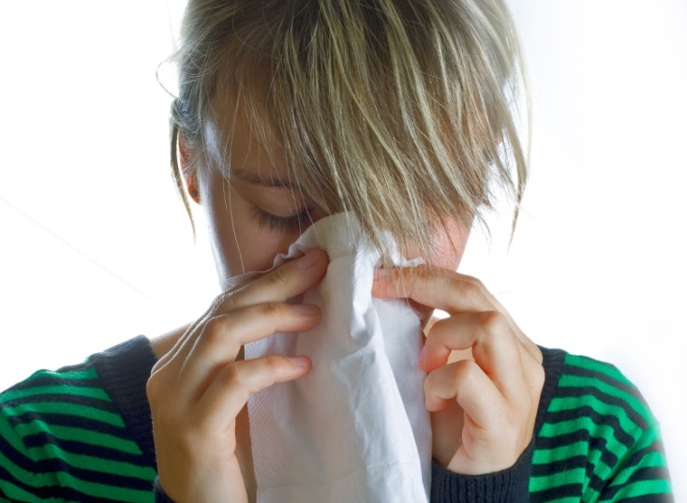

Use tissues when you sneeze to help stop infections spreading

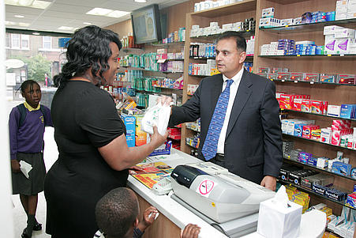

Ask your pharmacist for advice on reducing

your symptoms

Take paracetamol to reduce a fever; always follow the instructions

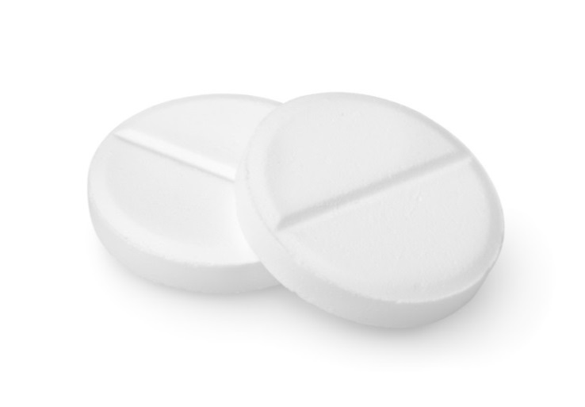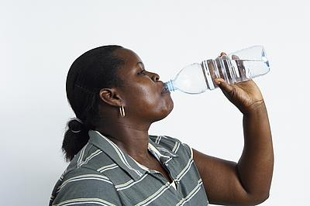

Drink enough fluids to avoid feeling thirsty



Get plenty of rest until

you feel better